|  |  |
| --- | --- |
|  | **Find the Factor** |
| **Problem Statement:**  Determine the factors of a number (i.e., all positive integer values that evenly divide into a number) and then return the pth element of the list, sorted ascending. If there is no pth element, return 0.  Example n = 20  p = 3  The factors of 20 in ascending order are {1, 2, 4, 5, 10, 20}. Using 1-based indexing, if p =  3, then 4 is returned. If p > 6, 0 would be returned.  Function Description  Complete the function pthFactor in the editor below.  pthFactor has the following parameter(s):  int n: the integer whose factors are to be found int p: the index of the factor to be returned  Returns:  int: the long integer value of the pth integer factor of n or, if there is no factor at that index, then 0 is returned  Constraints 1 ≤ n ≤ 1015  1 ≤ p ≤ 109  Input Format for Custom Testing  Input from stdin will be processed as follows and passed to the function. The first line contains an integer n, the number to factor.  The second line contains an integer p, the 1-based index of the factor to return.  Sample Input  STDIN Function  10 → n = 10  3 → p = 3  Sample Output 5  Explanation  Factoring n = 10 results in {1, 2, 5, 10}. Return the p = 3rd factor, 5, as the answer. | |

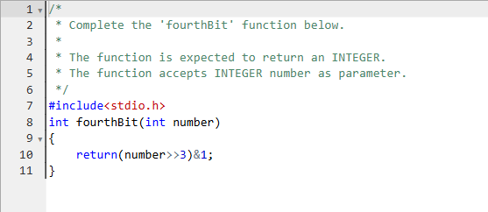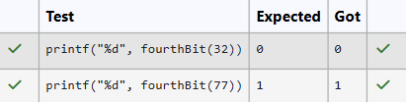

|  |  |
| --- | --- |
|  | **Prime or Not?** |
| **Problem Statement:**  Given an integer, if the number is prime, return 1. Otherwise return its smallest divisor greater than 1.  Example n = 24  The number 24 is not prime: its divisors are [1, 2, 3, 4, 6, 8, 12, 24]. The smallest divisor  greater than 1 is 2.  Function Description  Complete the function isPrime in the editor below.  isPrime has the following parameter(s): long n: a long integer to test  Returns  int: if the number is prime, return 1; otherwise returns the smallest divisor greater than 1  Constraints 2 ≤ n ≤ 1012  Input Format for Custom Testing  Input from stdin will be processed as follows and passed to the function. The only line of input contains the long integer to analyze, n.  Sample Input  STDIN Function  2 → n = 2 Sample Output  1  Explanation  As 2 is a prime number, the function returns 1. | |